AASHUTOSH MISHRA
1NT22CS002

Q.2.) Write scala code to find the length of each words from the array. Write a function to find the length of each word and return the word with highest length .
Ex for the collection of words = (“games”, “television”,”rope”,”table”)
The function should return (“television”,10). The word with the highest length .
Read the words from the keyboard.

Code:
import scala.io.StdIn._

object LongestWordFinder {

def findLongestWord(words: Array[String]): (String, Int) = {
// Find the word with the maximum length
val longestWord = words.maxBy(_.length)
(longestWord, longestWord.length)
}

def main(args: Array[String]): Unit = {
println("Enter words separated by spaces:")
val input = readLine()
val words = input.split("\\s+")

if (words.nonEmpty) {
val (word, length) = findLongestWord(words)
println(s"The longest word is: '$word' with length $length")
} else {
println("No words were entered.")
}
}
}

output:
student@student-HP-Pro-Tower-280-G9-E-PCI-Desktop-PC:~/ashutosh$ scala LongestWordFinder
Enter words separated by spaces:
cse nmit computer sciece
The longest word is: 'computer' with length 8

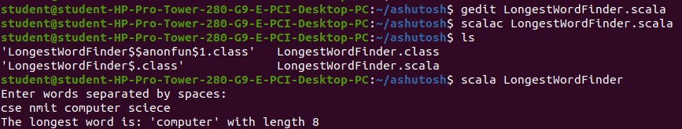

Q.3.) Write scala code to find the number of books published by each author, referring to the collection given below, with (authorName, BookName) { (‘ Dr. Seuss’: ‘How the Grinch Stole Christmas!’) ,(‘ Jon Stone’: ‘Monsters at the End of This Book’ ), (‘ Dr. Seuss’: ‘The Lorax’ ) ,( ‘Jon Stone’: ‘Big Bird in China’ ) ( ‘ Dr. Seuss’ :’ One Fish, Two Fish, Red Fish, Blue Fish’ ) }

code:

object BookCountByAuthor {

def countBooksByAuthor(books: Seq[(String, String)]): Map[String, Int] = {
// Group the books by author and count how many books each author has
books.groupBy(_._1).mapValues(_.size) // No need for .view here
}

def main(args: Array[String]): Unit = {
// Given collection of books with author names and book titles
val books = Seq(
("Dr. Seuss", "How the Grinch Stole Christmas!"),
("Jon Stone", "Monsters at the End of This Book"),
("Dr. Seuss", "The Lorax"),
("Jon Stone", "Big Bird in China"),
("Dr. Seuss", "One Fish, Two Fish, Red Fish, Blue Fish")
)

// Count the number of books per author
val bookCount = countBooksByAuthor(books)

// Print the result
println("Books published by each author:")
bookCount.foreach { case (author, count) =>
println(s"$author has published $count book(s).")
}
}
}

output:
student@student-HP-Pro-Tower-280-G9-E-PCI-Desktop-PC:~/ashutosh$ gedit BookCountByAuthor.scala
student@student-HP-Pro-Tower-280-G9-E-PCI-Desktop-PC:~/ashutosh$ scalac BookCountByAuthor.scala
student@student-HP-Pro-Tower-280-G9-E-PCI-Desktop-PC:~/ashutosh$ scala BookCountByAuthor
Books published by each author:
Jon Stone has published 2 book(s).
Dr. Seuss has published 3 book(s).
